SIMATS ENGINEERING
ASSESSMENT TOOL 2
COURSE NAME: Fundamentals of Data Science COURSE CODE:DSA0402
STUDENT NAME:M.Sadhana
Register No:1924260086

Concept Mapping

1. A college wants to analyze student performance using attendance records, internal marks,assignment scores, and final exam results. Draw a concept map showing the Data Scienceprocess from data collection to data transformation.

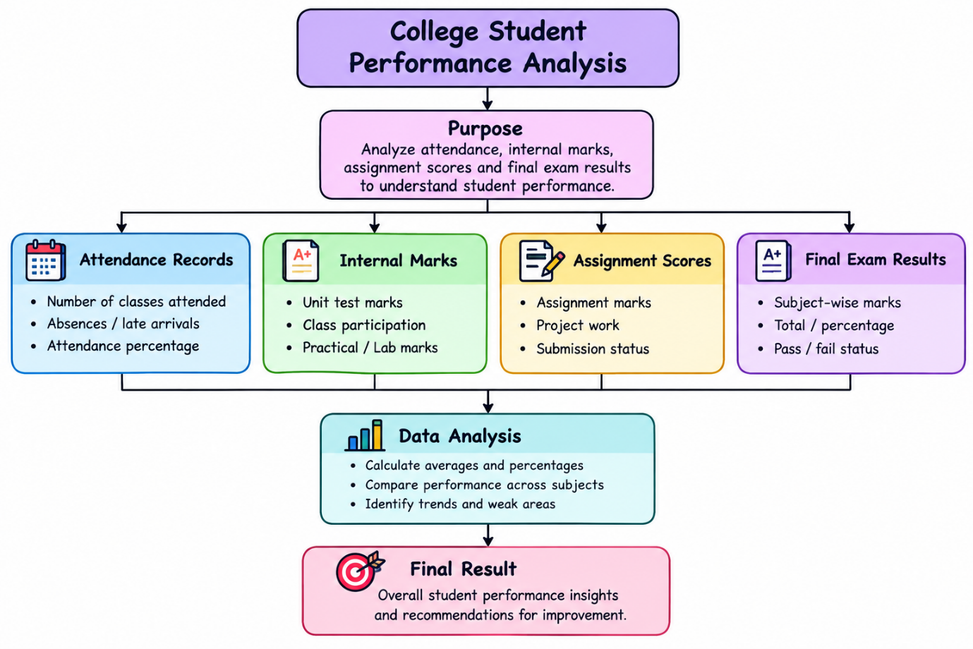

2. A hospital collects patient details from registration forms, lab reports, medical devices, anddoctor notes. Construct a concept map showing the different data collection sources and howthey are used for analysis.
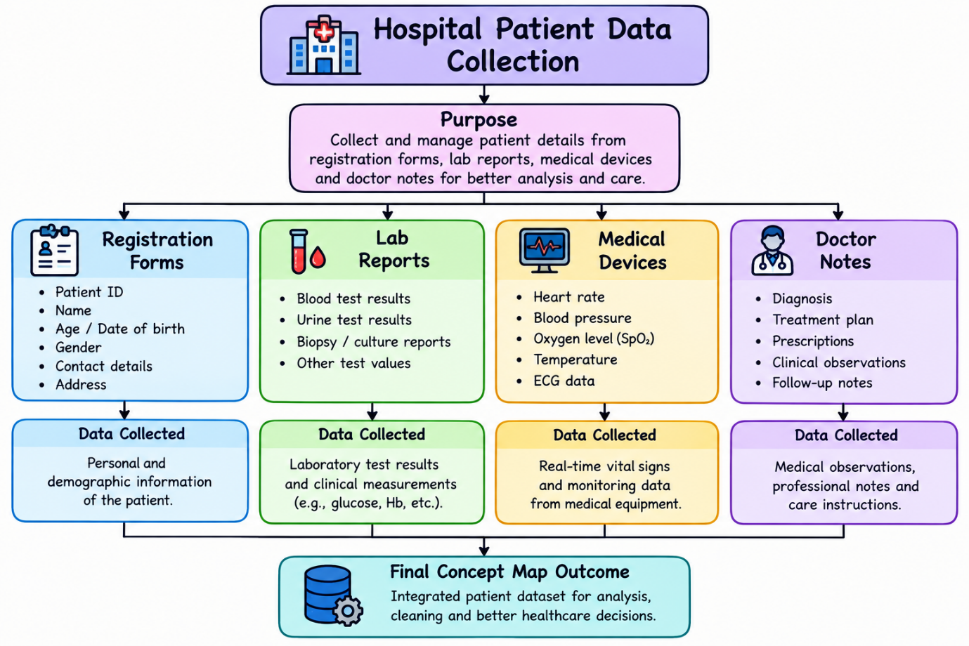

3. An online shopping company finds missing customer details, duplicate orders, wrongproduct entries, and unusual purchase amounts in its dataset. Draw a concept map showingthe data cleaning steps required before analysis.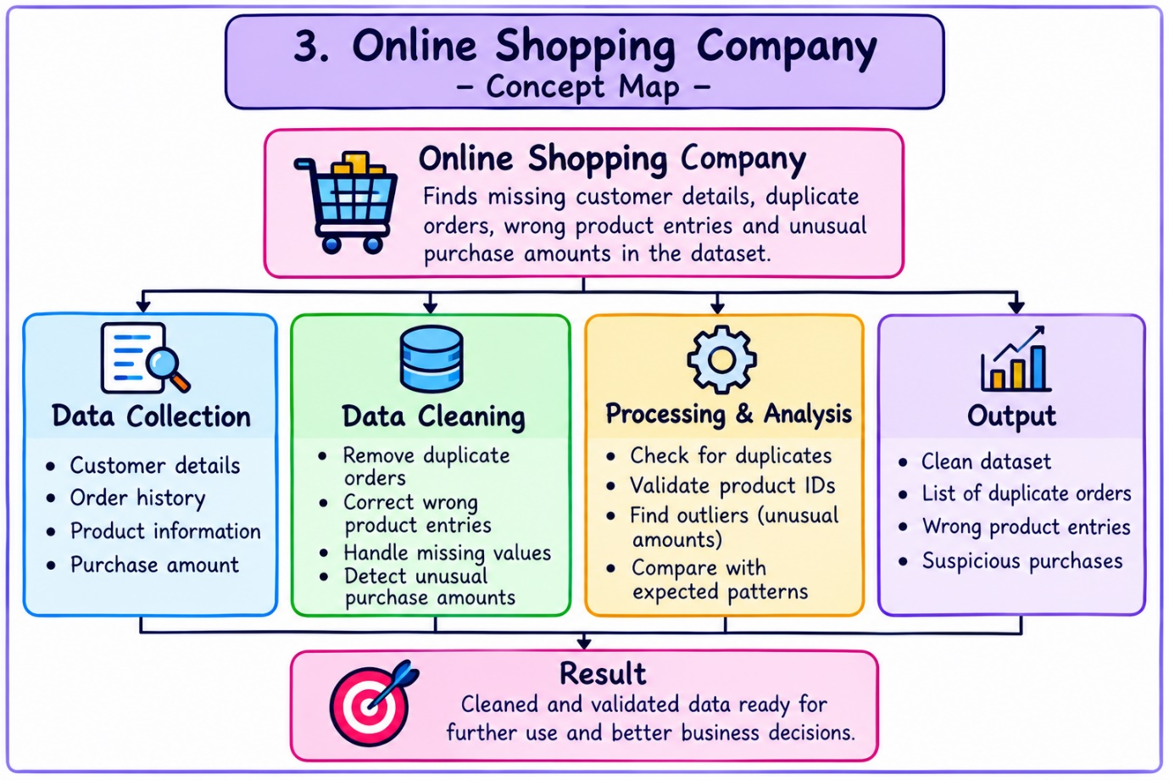

4. A smart city project collects traffic data from CCTV cameras, GPS devices, sensors, andmobile applications. Prepare a concept map showing how data from multiple sources can be integrated into a single dataset. 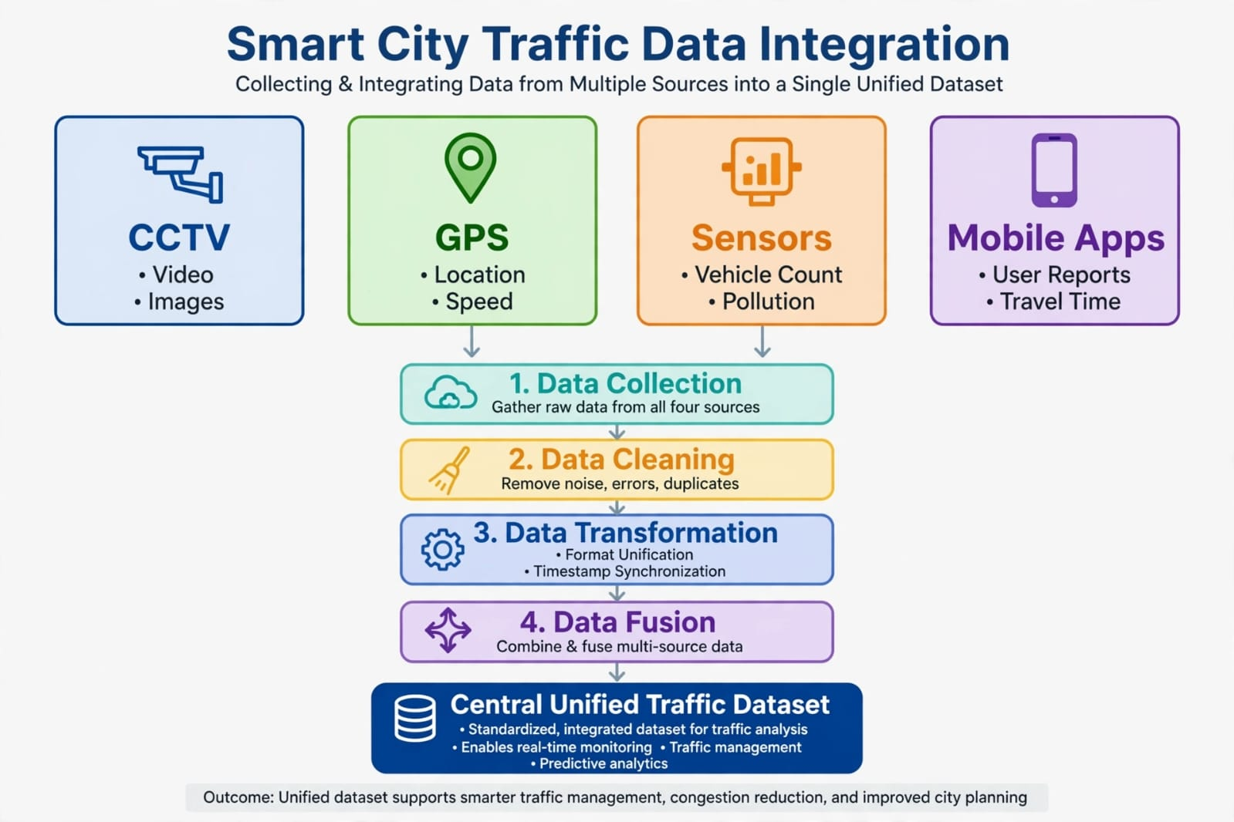

5. A bank wants to prepare customer data for loan approval prediction. The dataset containsincome, age, job type, loan amount, and credit score. Draw a concept map showing suitable data transformation techniques such as encoding, normalization, and feature scaling. 